SOP – How to Create a New Price Segment

Step 1: Open Context Parameter
- Login to UPC
- Go to Catalog → Common Configurations → Context Parameter
- Search for Customer Segment
- Under Actions, click Edit

Step 2: Modify Context Parameter
- In the Modify Context Parameter window, turn ON Apply Immediately
- Under Context Value, fill the below details:
3. Parameter Value Type – Fixed
4. Context Parameter ID – Enter a unique continuation number (follow the existing series; for example, if 1006 is present, use 1007)
5. Context Value – Enter the name of the requested price segment
- Click Attach

Step 3: Verify and Submit
- Verify the added details in the list below
- Click Submit

Next Step
After the price segment is created, follow the Product Offer Price SOP to add or update the price segment

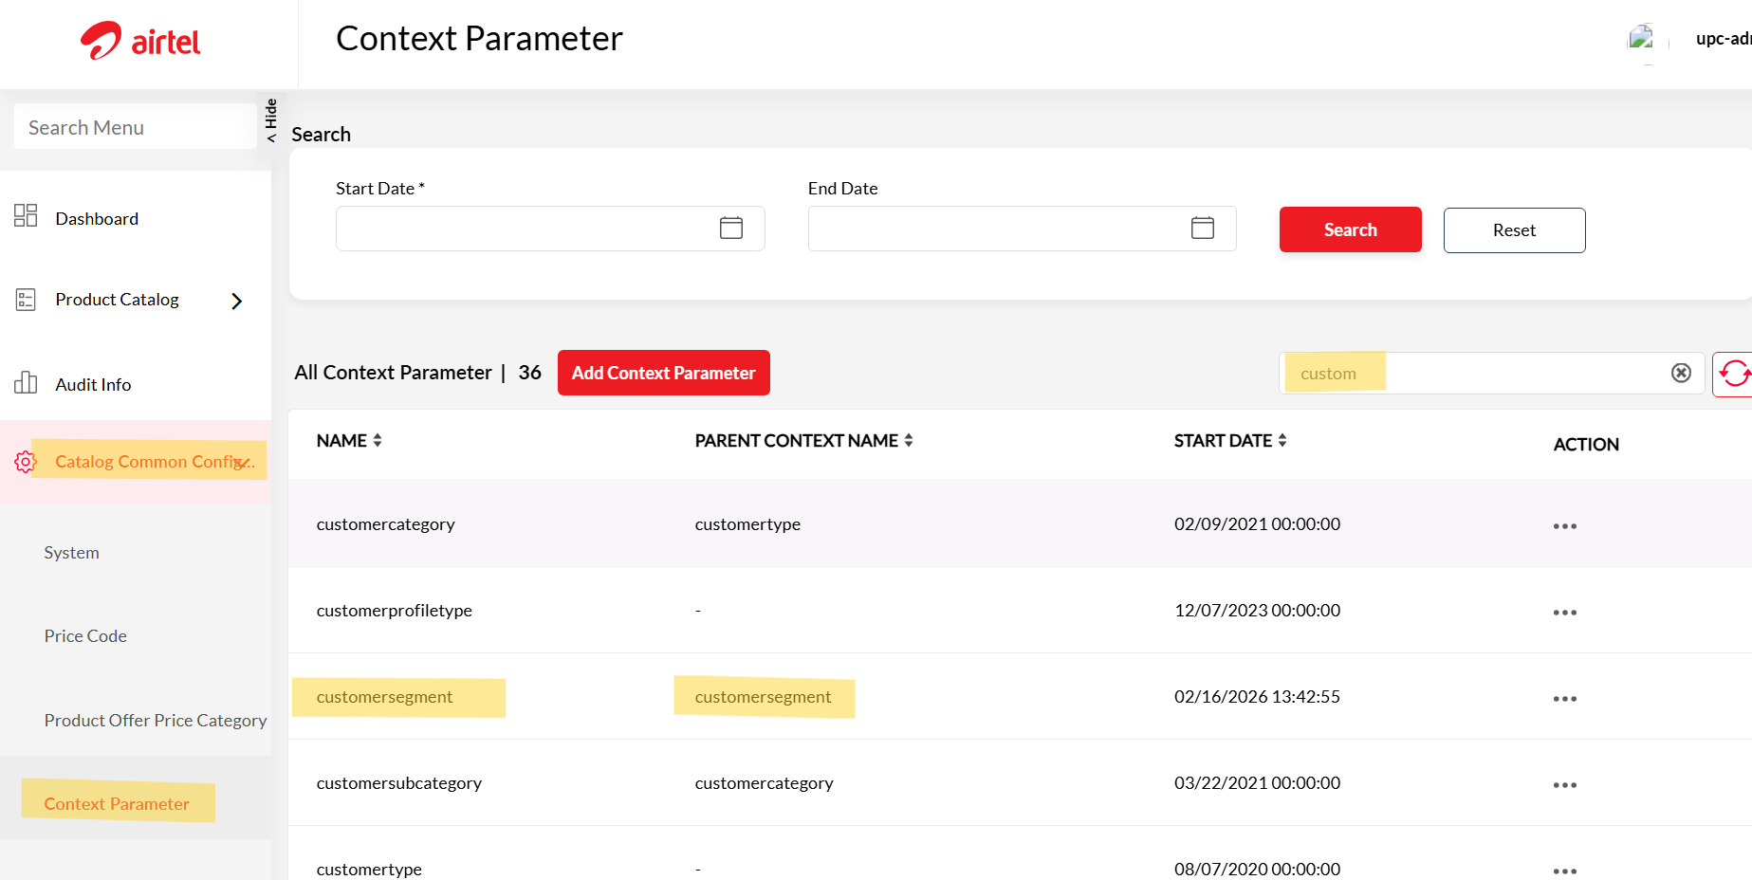
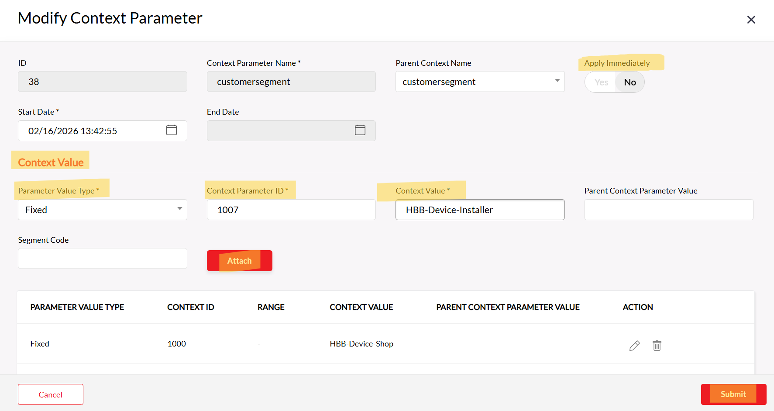

SOP – How to Add or Update Price Segment to product in UPC Portal

Step 1: Check Existing Price Segment
- Login to UPC Portal.
- Go to Product Catalog → Product Offer.
- Click on All Product Offers.
- Search for the product using the Product Name.
- Open the product and go to the Product Offer Price tab.
- Copy the Price Name (this will be needed later).
- Check the existing Price Segment.
If the requested price segment is already available, no changes are needed.
If it is NOT available, follow the steps below.

Step 2: Open Product Offer Price for Editing
- Go to Product Catalog → Product Offer Price.
- Search using the Price Name (the one you copied earlier).
- Under Actions, click Edit.
- Turn ON the toggle for Apply Immediately.

Step 3: Edit or Add Dynamic Price Segment
Scroll to the All Dynamic Price section.

A) If You Need to Edit an Existing Dynamic Price:
- Click Edit on the required “If” condition.
- Under Value, add the required price segment.
- Click Add.
- Click Yes to confirm.
- Verify the changes.
- Click Submit.

B) If You Need to Add a New Dynamic Price:
- Click Add New Dynamic Price.
- Fill in the required details.
- Under Value, add the requested price segment.
- Click Add.
- Click Yes to confirm.
- Verify the changes.
- Click Submit.

Final Check
After submission, verify that the new price segment is updated correctly in the Product Offer.


